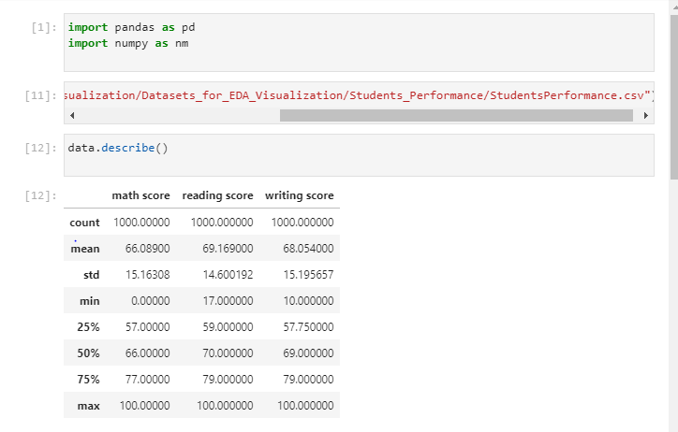

# Probability of student getting above 60 in reading

Code:-

total_students = data.shape[0]

students_score_more_than_60 = data[data['reading score'] > 60].shape[0]

probability_of_students_scoring_more_than_60_in_reading =(students_score_more_than_60/total_students)*100

print("probability of student scoring more than 60 marks in reading :",probability_of_students_scoring_more_than_60_in_reading)

output:-

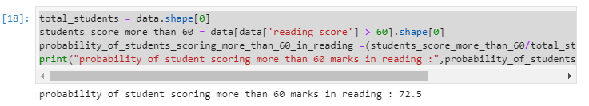

# Probability of student getting above 90 in reading

Code:-

total_students = data.shape[0]

students_score_more_than_90 = data[data['reading score'] > 90].shape[0]

probability_of_students_scoring_more_than_90_in_reading =(students_score_more_than_90/total_students)*100

print("probability of student scoring more than 90 marks in reading :",probability_of_students_scoring_more_than_90_in_reading)

Output:-

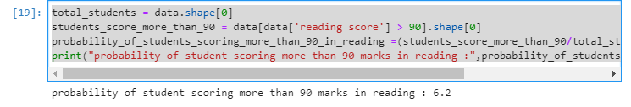

# Probability of student getting above 35 in reading

Code:-

total_students = data.shape[0]

students_score_more_than_35 = data[data['reading score'] > 35].shape[0]

probability_of_students_scoring_more_than_35_in_reading =(students_score_more_than_35/total_students)*100

print("probability of student scoring more than 35 marks in reading :",probability_of_students_scoring_more_than_35_in_reading)

Output:-

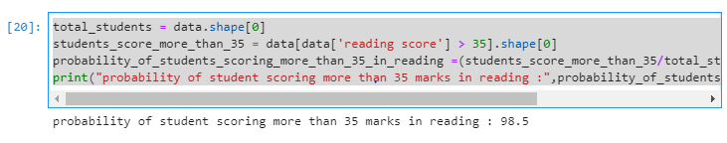

# Probability of student getting less then 35 in reading

Code:-

total_students = data.shape[0]

students_score_less_than_35 = data[data['reading score'] < 35].shape[0]

probability_of_students_scoring_less_than_35_in_reading =(students_score_less_than_35/total_students)*100

print("probability of student scoring less than 35 marks in reading :",probability_of_students_scoring_less_than_35_in_reading)

Output:-

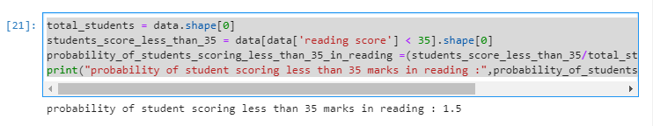

# Probability of students passing in reading

Code:-

total_students = data.shape[0]

number_of_student_passing_in_reading = data[data['reading score'] > 35].shape[0]

number_of_student_passing_in_reading =(students_score_more_than_35/total_students)*100

print("number_of_student_passing_in_reading:",number_of_student_passing_in_reading)

output:-

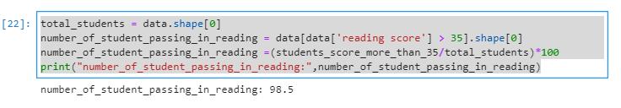

# Number of female scoring 90+ in reading

Code:-

data[(data['gender'] == 'female') & (data['reading score'] > 90)]

Output:-

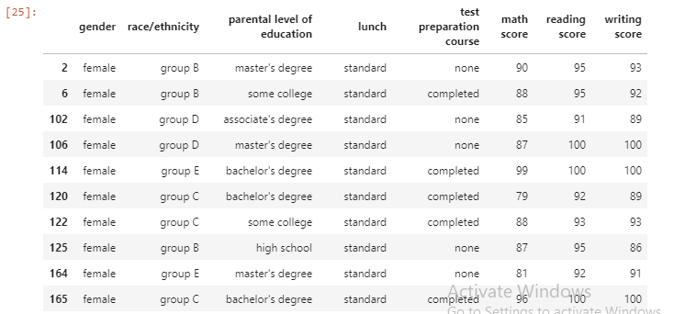

# Number of male scoring 90+ in reading

Code:-

data[(data['gender'] == 'male') & (data['reading score'] > 90)]

Output:-

